**CURRICULUM VITAE FOR AYENI OLUWASEGUN ELIJAH**

1. **Personal Data:**
2. Full Name (Surname first): AYENI Oluwasegun Elijah
3. Date of Birth: 27th May, 1994
4. Details of Contact Addreess:
   1. E-mail Address(es): [oayeni@unimed.edu.ng](mailto:oayeni@unimed.edu.ng), [oluwasegundynasty@gmail.com](mailto:oluwasegundynasty@gmail.com)
   2. Mobile Phone Number(s): 08065030085
5. Nationality: Nigerian
6. State of Origin: Ekiti
7. Local Government Area: Ijero
8. Permanent Home Address: 64 Ireakari Street, behind Hidden Manna Bible church, Ijetu, Osogbo, Osun State
9. Marital Status: Married
10. Number of Children and their Ages: Nil
11. Next of Kin: Mrs. Grace Ayeni
12. Details of Contact Address of Next of Kin:
    1. E-mail Address(es): graceoluwabunmitaiwo@gmail.com
    2. Mobile Phone Number(s): 08138546949
    3. Permanent Home Address: 64 Ireakari Street, behind Hidden Manna Bible church, Ijetu, Osogbo, Osun State
13. **Educational Background:**
14. Higher Educational Institutions Attended with Dates:
15. **University of Medical Sciences, Ondo 2022-2024**
16. **Obafemi Awolowo University, Ile-Ife 2014-2019**
17. Academic/Professional Qualifications and Distinctions Obtained with Dates
18. **Masters of Science, Public Health (MSc.PH) 2024**
19. **Bachelor of Medical Rehabilitation (BMR (OT)) 2019**
20. Other Distinctions and Awards with Dates
    1. Scholarship: Nil
    2. Fellowship: Nil
    3. Research Grants: Nil
    4. National Awards: Nil
    5. International Awards: Nil
21. **Work Experience with Dates:**

**Lecturer II:** Department of Occupational Therapy, University of Medical Sciences, Ondo State, Nigeria.

1. Previous Work Experience outside the University System with Dates
2. **Occupational Therapist 2021-2022**

State Specialist Hospital, Osogbo, Osun State

1. **Intern Occupational Therapist 2019-2020**

State Specialist Hospital, Osogbo, Osun State

1. Previous Work Experience in other University: Nil
2. Work Experience in University of Medical Sciences
   1. Thirty Percent (30%) Core Curriculum Minimum Academic Standard (CCMAS) development for Bachelor of Occupational Therapy (B.OT) programme.
   2. Member, Faculty Board
   3. Intra-faculty lecturing and exam supervision
   4. Students’ Project supervision: 2 (Department of Prosthetics and Orthotics Conversion Students (2022/2023))
3. Ojelabi Adebayo Hezekiah
4. Abannikanda Kehinde Habeebat
5. Courses taught within the Current Academic Session
6. POT 327: Therapeutic Skills in Splinting, Slings and Bandages for regular (300 Level Prosthetics & Orthotics Department)
7. POT 327: Therapeutic Skills in Splinting, Slings and Bandages for regular and (Conversion students of Prosthetics & Orthotics Department)
8. POT 415: Mobility and walking aids
9. POT 511: Ergonomics
10. Graduate Student Supervision within Current Session: Nil
11. Current Undergraduate Supervision: Nil
12. **Membership of Professional Bodies:**
13. Member, Occupational Therapist Association of Nigeria (OTAN)
14. **Publications with Dates:**
15. Thesis/Dissertation: 2
16. Assessment of Occupational Engagement among in-patients psychiatric hospitals in selected hospitals in Southwest Nigeria
17. Ergonomic Design as determinant for the prevalence of Work-related Musculoskeletal Disorders among office-based Civil Servants in Ondo State, Nigeria
18. Published Journals Articles: 5
    1. Onigbinde A.T, Ajao D.D, Oyedemi J, Akinfolarin Y.T, Afolabi T. O, Afolabi A.D, Awotipe A, Borode K, Borode T, Ugwu C. A, Onigbinde O. M, **Ayeni O. E** (2023). Relationship between computer workstation ergonomics and spinal pain among non-academic staff in a Nigeria university community. Journal of Orthopaedic Manual Therapists, vol 1, No 1, 32 – 47.
    2. **Ayeni OE,** Olayemi MA, Onigbinde AT, Kekere TF, Ayinla SC. Comparative Analyses of Hamstring Tightness and Sitting Duration Among Professional and Non-Professional Drivers in a Nigerian Community. Eur J Med Health Res, 2024;2(3):61-70. DOI: 10.59324/ejmhr.2024.2(3).08
    3. Onigbinde,A.T;Omisore,O.Z;Adejumobi,A.S;Ayinla,S.C;**Ayeni,O.E**;Kekere,T.F. Comparative Effects of Magnesium Iontophoresis on Post Stroke Elbow flexors Spasticity. Journal Of Biomedical Investigation (JBI)Vol. 12 no. 1 April-May 2024
    4. **Ayeni OE,** Ibrahim DO, Onigbinde AT, Taiwo GO, Kekere TF, Ayinla SC, Akpa IV. Ergonomic Design as a Determinant for the Prevalence of Work-Related Musculoskeletal Disorders among Office-Based Civil Servants in Ondo State, Nigeria. Eur J Med Health Res, 2024;2(4):118-29. DOI: 10.59324/ejmhr.2024.2(4).16
    5. Lasisi K, Onigbinde AT, Ayinla SC, **Ayeni OE**, Kekere TF, Awotipe A, Borode AO, Ayodeji AO, Adeyemi T, Adewuni AS, Ibitoye AG, Ajao DD, Madume AK, Ugwu CA. Comparative Effects of Isometric Quadriceps Training, Glucosamine and Chondroitin Sulphate Iontophoresis on Pain Intensity and Physical Functions of Patients with Knee Osteoarthritis. Eur J Med Health Res, 2024;2(4):**DOI:** 10.59324/ejmhr.2024.2(4).
19. Articles Accepted for Publication: Nil
20. Manuscript Submitted for Publication: 1

***Title:*** *Comparative analysis of level of mobility and Quality of Life among lower limb amputees with or without prostheses in Lagos State, Nigeria*

***Journal:*** *Journal of Orthopaedics Trauma and Rehabilitation*

1. Paper and Work in progress: 2
2. Duration of Use and Satisfaction of Orthotic Devices among Children and Adolescents with Cerebral Palsy in Lagos State, Nigeria
3. Title: Barriers to Accessing Medical Rehabilitation Services among dwellers in Ondo State, Nigeria
4. **Professional Accomplishment: Nil**
5. **Conferences, Seminars and Workshops Attended with Dates**
   1. Assessment in Occupational Therapy: 2024 MRTBN CPD workshop for Occupational Therapist
   2. International Volunteering and Agenda 2063 digital Ambassadorial workshop; La Plage Meta Verse Workshop (Virtual, 2023)
   3. Occupation and Health: Prevalence of Work Related Musculoskeletal Disorders among Civil Servants in Ondo State.
   4. Positioning for Torticollis and Play- American International College Interprofessional Mentorship Training (2023-Virtual)
   5. Occupational and Health Needs of Children Experiencing Homelessness: Opportunities for Action and Advocacy; American International College Interprofessional Mentorship Training (2023-Virtual)
   6. Disaster management and preparedness- La Plage Meta Verse Workshop (2023-Virtual)
   7. Science of Mind, Healing and Innovation; Centre for Entrepreneurial Development and Innovation lecture (2023)
   8. Poliomyelitis and challenges of Social Integration; Seminar Presentation, School of Public Health, UNIMED (2023)
   9. Climate change, health and the environment; School of Public Health Grand Lecture (2022)
   10. Postgraduate Studies as catalyst for research, innovation and development; School of Postgraduate Lecture series (2022).
   11. Pedagogy training for academic staff- UNIMED Centre for Health Professions and Biomedical Education (CeHPBE) (2022)
6. **Current Research Activities:**
7. Relationship between duration of use and satisfaction of orthotics devices among children and adolescents with cerebral Palsy
8. Barriers to accessing rehabilitation services among community dwellers in Ondo state, Nigeria
9. **Current Relevant Information**
   * 1. Services within the Department:
     2. 100 Level Part adviser for B.OT students
     3. Programme Coordinator, Department of Occupational Therapy
     4. Services within the Faculty:
10. Member, Faculty Board of studies and Examiners.
11. Member, Faculty Research Committee
    * 1. Services within the University: Programme Coordinator, Department of Occupational Therapy.
      2. Services outside the University:
      3. Facilitator, Medical Rehabilitation Therapist Board of Nigeria (MRTBN) CPD workshop
      4. Reviewer, International Journal of Adolescent Medicine and Health.

Signature: 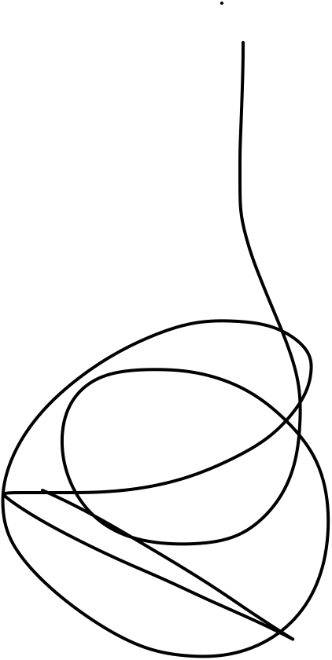 Date: 15th July, 2024