**CURRICULUM VITAE FORMAT FOR NON-TEACHING STAFF OF THE UNIVERSITY**

1. **Personal Data:**
2. Full Name: Otenaike Adejoke Ayoola
3. Date of Birth: 17th September, 1989
4. Details of Contact Addreess: Road 8, House 3, Ikoyi quarters, Ile-Ife, Osun State
   1. E-mail Address(es):
   2. Mobile Phone Number(s): 07033879262
5. Nationality Nigeria
6. State of Origin ogun State
7. Local Government Area Ijebu North Local Government
8. Permanent Home Address Road 8, House 3, Ikoyi quarters, Ile-Ife, Osun State
9. Marital Status
10. Number of Children and their Ages
11. Next of Kin Mrs Ayobami Otenaike
    1. Details of Contact Address of Next of Kin: Road 8, House 3, Ikoyi quarters, Ile-Ife, Osun State
    2. E-mail Address(es):
    3. Mobile Phone Number(s): 08038414028
    4. Permanent Home Address:
12. Date of Assumption of Duty: 1st April, 2022
13. Rank/Status of First Appointment: Clerical officer
14. Present Status: Clerical officer
15. Date of Last Promotion:
16. Present Salary, Grade Level and Step: Contiss 3 Step 3
17. Date of Confirmation of Appointment:
18. Faculty/Directorate: Public Relations
19. Unit: Public Relations
20. **Educational Background:**
21. Higher Educational Institutions Attended with Dates: Federal Polytechnic Offa, HND, 2017
22. Academic/Professional Qualifications and Distinctions Obtained with Dates: HND, 2017
23. Other Distinctions and Awards with Dates
24. **Work Experience with Dates:**
25. Work Experience in University of Medical Sciences

A worked as clerical officer at Public Relations Department 2022 till date

1. Previous Work Experience in other University
2. Previous Work Experience outside the University System with Dates

Wamco Nigeria limited (Peak Milk) 2017-2020

1. **Membership of Professional Bodies**
2. **Professional Accomplishment:**
3. **Conferences, Seminars and Workshops Attended with Dates:**

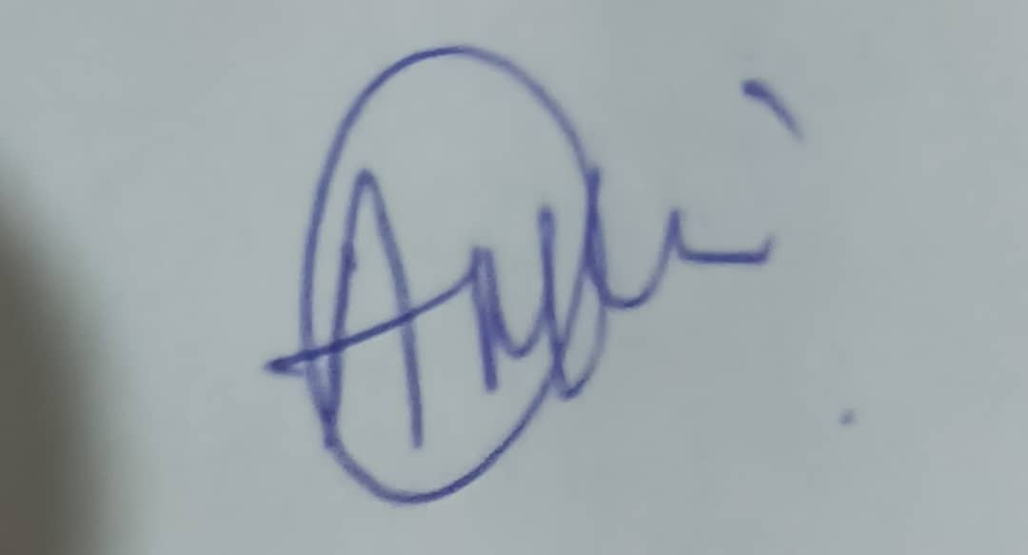

Signature: ……………………………………………. Date: 22nd July, 2024